Hybrid Applications

Fat client applications accessing remote data via HTTP

By:

Kevin J. Cully
Cully Technologies, LLC
President

http://www.cullytechnologies.com
http://www.cullytechnologies.com/presentations

INTRODUCTION

This presentation draws strongly from the following article from West-wind: http://www.west-wind.com/presentations/wchttp.htm and is based on the Web Connection product.

Everyone has been caught up in web development. HTML, ASP, Cold Fusion, CGI, Perl, and other web centric technologies were new, exciting, and simple. Simple but with easy distribution.

We’ve grown in experience, extended our abilities, and we’re seeing the issues a bit clearer now. Thin client applications often fall short on user interface and control. Fat client applications don’t scale well and are difficult to distribute and update.

A hybrid application hopefully takes advantages of the strengths of each approach. If your requirements are for a rich user interface but allow for centralized data, a hybrid application paradigm is just the ticket.

One thing to keep in mind, though: Although you are not using HTML to display the output, you still need a backend Web application as discussed in previous Web articles. You still need to run a Web server and some backend software such as Web Connection, or Active Server Pages to provide the server portion of your application. To demonstrate the correlation in the data transfer, we allow for conditionally either sending back HTML pages or a XML document.
THE WEB APPLICATION

I’ve started by creating a typical web application with query, list, and detail functionality.

Following is a screen capture of the Web Connection application that accepts our web hits from both the browser and the hybrid application. You can see that the hit times are very modest.

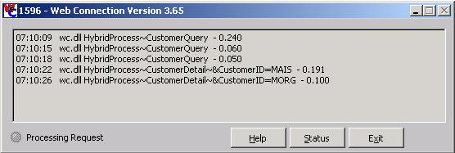

Here’s a typical query screen in a browser. I’ve already typed in my criteria and pressed the “Submit” button, retrieving every customer where their customer name begins with “M”. Notice that in this instance, we have chosen to have the output sent back to us as HTML and not XML. More on this later.

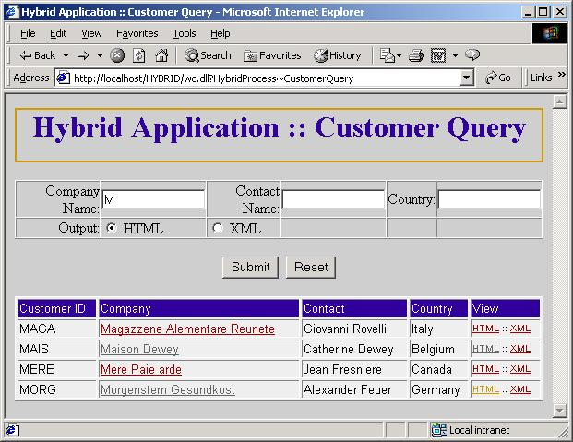
When we click on the “Maison Dewey” link in the HTML, it takes us to the detail page that not only shows us the detail of the customer information, it’s also displaying the order history.

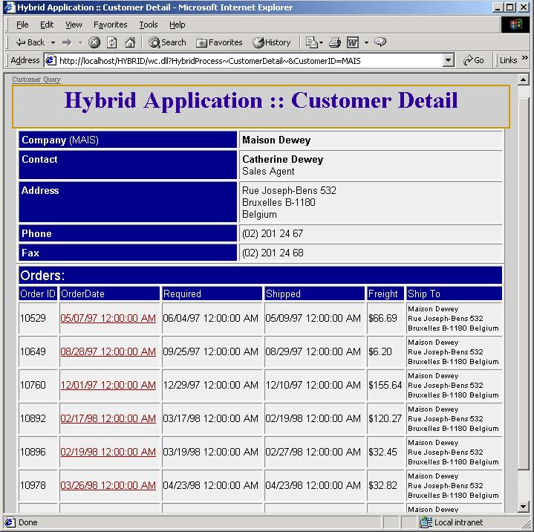

A LOOK AT THE XML OUTPUT

If we, from the Customer Query screen, request that we receive our information in XML format from our Internet Explorer browser, we receive it in this format. A special note should be made that we aren’t sending back this information with a DTD (Document Type Definition). A DTD contains information regarding the structure of the XML document. In the case of a data based XML document, the DTD would contain information that would allow the data to be reconstructed into a new data structure. DTDs are rapidly giving way to ‘schemas’. Web Connect also can generate these schemas. Because we don’t have the DTD or a schema tied to this XML, this mandates that the receiving application knows something about the data in order to reconstitute it.

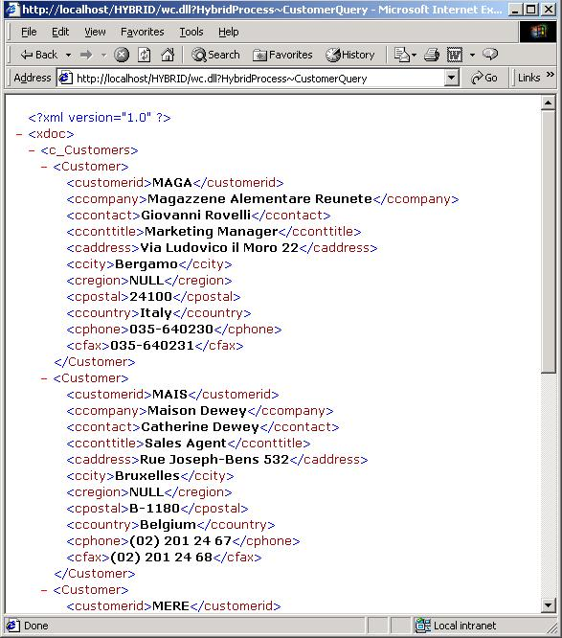

Choosing the detail view with the XML output option generates this XML result. This XML document includes two different data sets: the parent and child information. In this instance it’s the customer record and all of the relating order records.

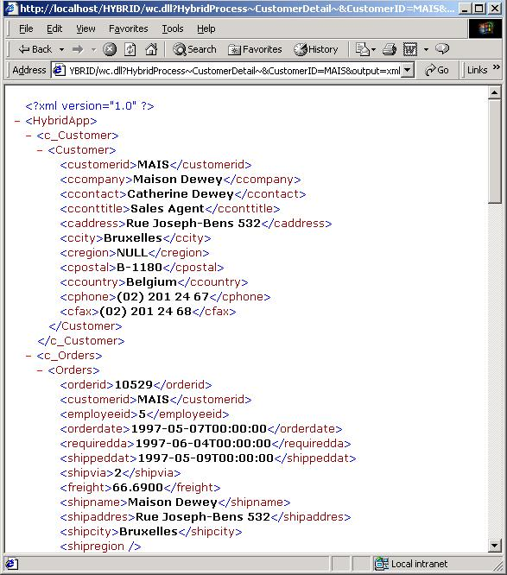

FAT CLIENT HYBRID APPLICATION

Our client application is going to simulate a browser when it communicates back to the web application. Web Connection makes this almost trivial. The fat client application allows for a richer experience with tighter validation control.

Our application consists of a very simple query, list, and detail view of our data. Similar to the web based application, we’re querying for the information where the Company Name begins with an ‘M’.

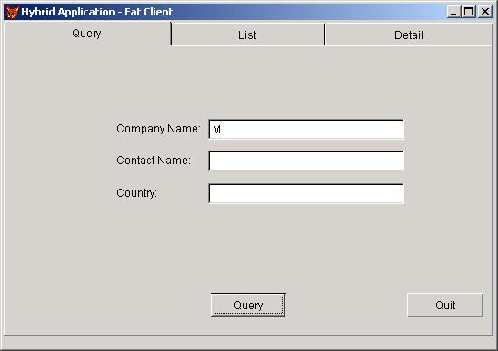

When the Query button is pressed, a server hit is executed, resulting in an XML document getting passed back to the application. This XML is then converted back into a VFP cursor, bound to a grid on the list tab and displayed.
Here’s our data, bound to the grid. This information is the same data that was served as HTML and XML over the web in a browser.

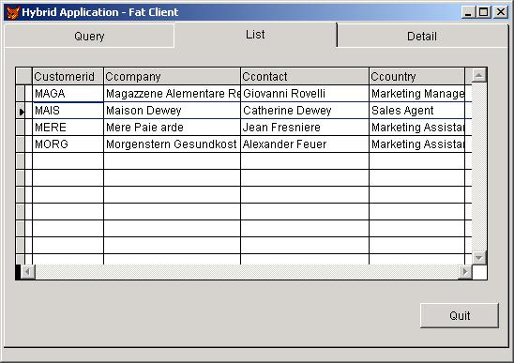

To view the detailed information, click onto one of the records and then click the ‘Detail’ tab.
Once the ‘Detail’ tab is clicked on, our second server hit is executed. The response includes our combined XML document that is parsed back into VFP cursors. The ‘Orders’ grid is then bound to the orders cursor. The information is then displayed.

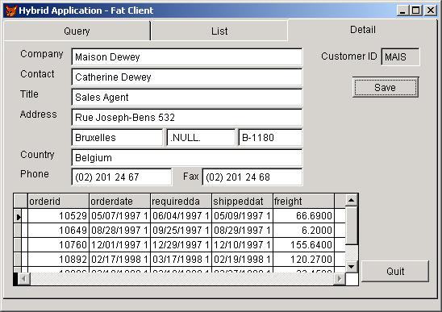

This fat client application allows for the changing of the data. Once the user makes the changes to the Company information, they can click on the ‘Save’ button. The record is bundled up into an XML document and posted back to the server. This time, we’ve included a DTD for demonstration purposes. (refer to the code page with the method: CompanyDetailSave for the appropriate code.)
WEB SERVER APPLICATION CODE

The server application accepts form variables whether taken from the HTML posting or our client application. We then gather it all up and execute our select against our VFP tables. I’ve written the select statement so that it is easily converted into a MS SQL Server style select. If using SQL Server, just concatenate the information into a string and use pass-through to execute the select for you.

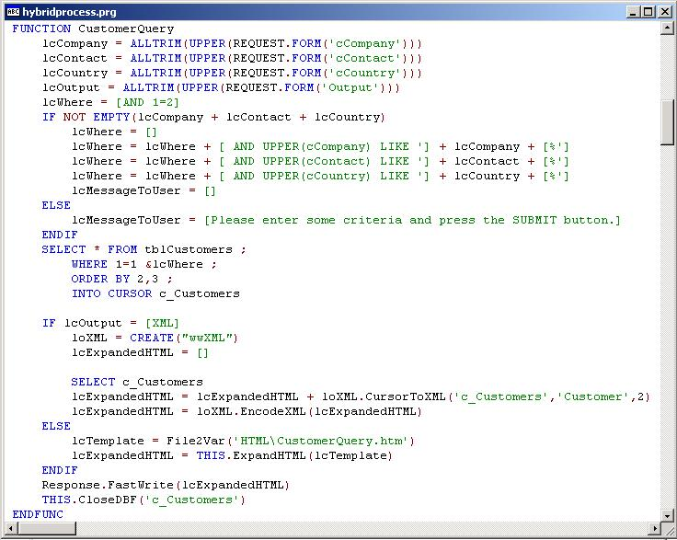

Notice that if the lcOutput is equal to the string ‘XML’ then we convert the VFP cursor to a XML string and pass that as the result back to the requestor, whether it is a browser or an application.
The CustomerDetail method (function) combines two XML documents into one if the resulting output is requested to be XML. This only takes a few more lines of code to custom add our XML header.

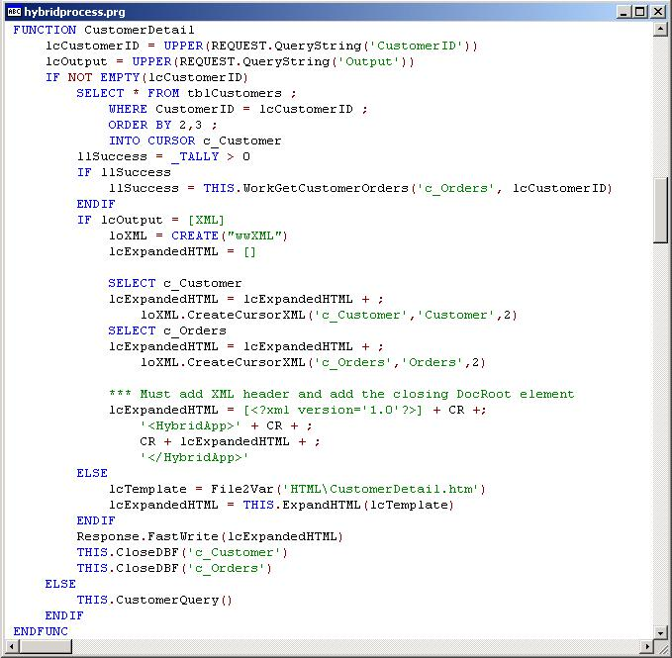

FAT CLIENT APPLICATION CODE

Our client application instantiates the free class library wwIPStuff to conduct our web communications. All we are left to do is specify the URL, add some post variables, and tell it to go. As with most HTTP communications, our response comes to us as a string. If the string is XML, we create data out of it and display. If the response contains an error, then we display that information raw in a MessageBox. Notice that our VFP form handles all of our display particulars.

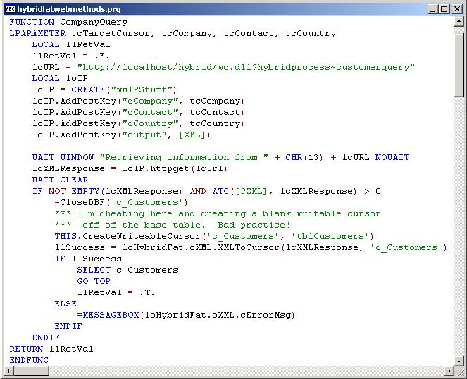

The CompanyDetail method is expecting a response containing two XML nodes in it. This takes just a bit more code to set the nodes and then convert them into data.

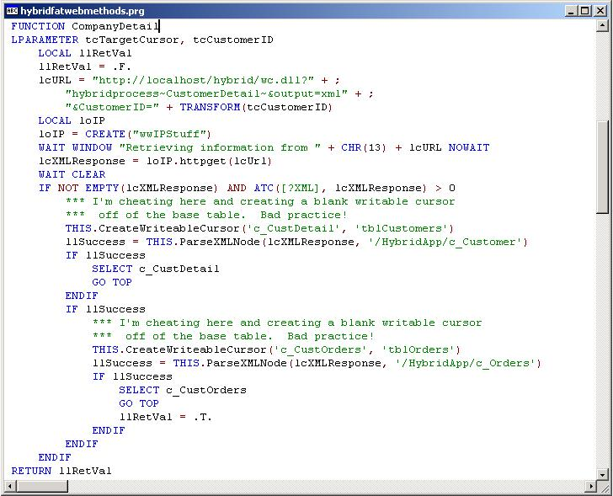

To post our changed information, we create XML out of our data, this time with a DTD! We take that XML document and add it as a post variable and then post the information. In this instance, the response is very simple so we display it in a MessageBox.

To generate a schema instead of a DTD only required that you add the following lines:
loXML.nCreateDataStructure = 1
loXML.cSchemaName = 'CustomerDetail'

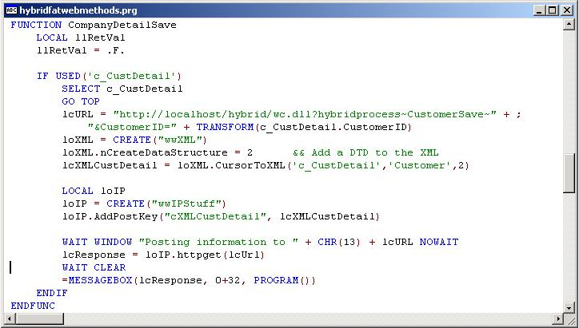

WEB APPLICATION SAVE CODE

On the server side of things, we retrieve our CustomerID and the XML. If we can find the customer, we convert the XML into data, scatter that to a memory object, select the target table and then gather from that same memory object. Notice we’re not handling the creation of a new record, but that would just involve inserting the new record instead of updating an existing record. Also notice that since the XML contains a DTD, we don’t need the target cursor before we turn the XML into data. The DTD allows for the creation of the cursor and then the data is dumped into it.

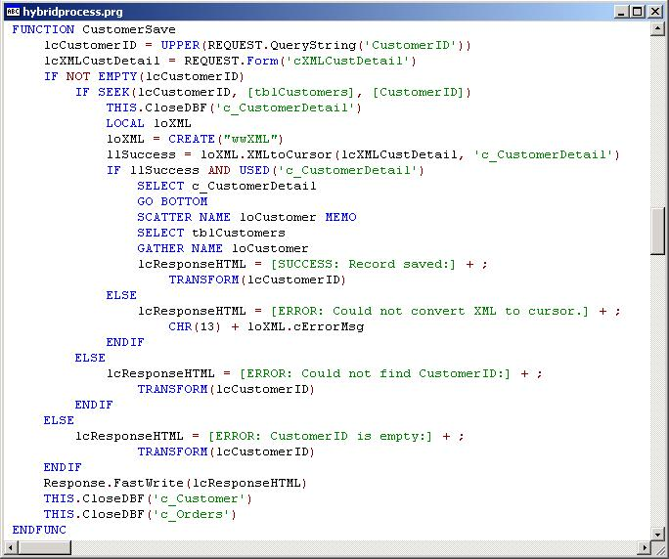

SUMMARY

I hope that I’ve demonstrated how a hybrid application might be a powerful addition to your application arsenal. Not every application will fit into either the ‘web’ category or the ‘fat client’ category. It’s all about using the right application of technology for the requirement at hand.

Visual FoxPro continues to be one of the best tools for accessing data EVER! You can see that in regards to its easy transition to the web.

